KIET DIGITAL LIBRARY
OpenUser Module
Technical Documentation
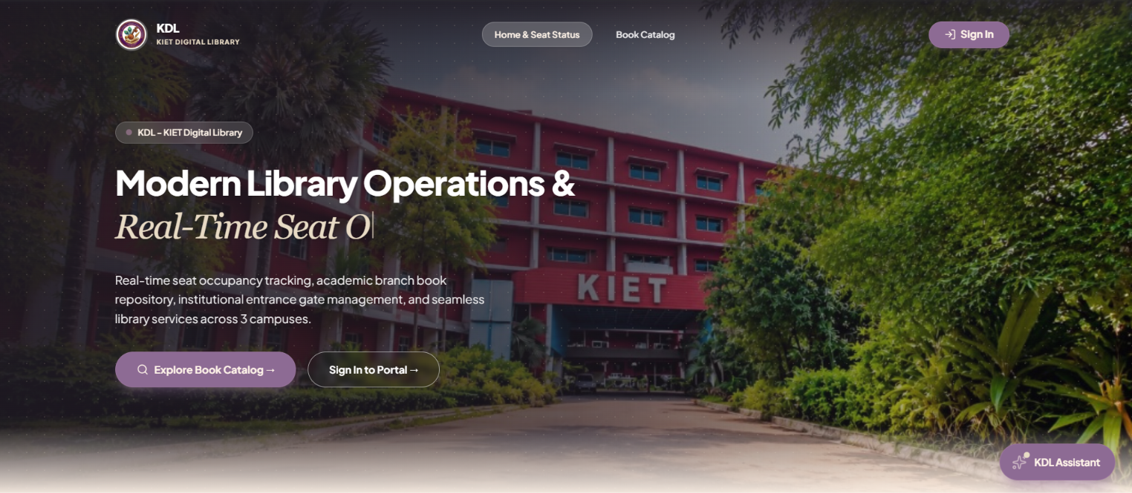
Public-facing library discovery, catalogue and availability experience

DEVELOPMENT TEAM
Rajini — Developer Intern
Naveen Kumar — Junior Developer
MY LEARNINGS
Completed Learning
- JavaScript – Basics, Promises, Async/Await, and DOM.
- Node.js – Basics, npm, modules, and server-side development.
- Express.js – REST APIs, Routing, Middleware, and CRUD.
- MongoDB – NoSQL, CRUD, Atlas, Compass, and Mongoose.
- Authentication – JWT, Authorization, and Protected Routes.

Current Learning
- React.js – Components, JSX, Props, State, Hooks, Routing, Forms, and API Integration.
Familiar With
- shadcn/ui – Reusable UI components.
- Recharts – Charts and data visualization in React

01 / OVERVIEW

Project & OpenUser Overview
A focused technical view of the public-facing module of KDL.

2.1 Project Overview

KDL — KIET Digital Library is a web-based library management platform designed to provide digital access to library services and information. The system supports library discovery, book catalogue access, availability information, and library entry/exit management

2.2 OpenUser Module

OpenUser is the public-facing module of KDL. It allows users to explore available libraries, check library status and seat availability, and browse the book catalogue without requiring a registered account.
The module is designed as a view-oriented interface, providing quick access to library and book information while keeping administrative and borrowing operations restricted to authorized users.

Capability | What the user can do
Library Status | View active campus libraries, codes, locations and operational timings.
Seat Availability | View current occupancy/availability information with live synchronization.
Book Catalogue | Browse the public academic catalogue and availability indicators.
Book Search & Filter | Search by title, author, ISBN or Book ID and filter by academic branch and library.
Book Details | Inspect publisher, edition, copy-status information and holding distribution.

OpenUser provides a public gateway to CLMS, enabling users to discover libraries, monitor availability and explore books through a unified web interface.

02 / TECHNOLOGY

Technology Stack
Technologies used by the OpenUser implementation.
Layer | Technology | Role
Frontend | React.js | Component-based public interface.
Language | JavaScript / JSX | UI logic and application behavior.
UI | shadcn/ui | Reusable interface components.
API | REST API modules | Frontend-to-backend communication.
Backend | Node.js + Express.js | Routing and application/business layer.
Realtime | Server-Sent Events (SSE) | Live occupancy synchronization.
Database | MongoDB + Mongoose | Centralized persistence and models.
Development | Git + GitHub | Version control and collaboration.
IDE | VS Code / Antigravity | Development and debugging.

Development Approach
OpenUser follows a full-stack MERN development approach. The frontend consumes backend APIs rather than acting as the source of truth. Backend services process data through the application layer and Mongoose models.

Team
Rajni and Naveen Kumar contributed to OpenUser development across frontend implementation, backend/API integration and feature-level testing. Final contribution wording should be aligned with the team's actual work records.

03 / ARCHITECTURE

OpenUser Technical Architecture
Request, service and data flow across the public module.
USER / OPENUSER
↓
REACT FRONTEND
LandingPage • PublicCatalog • Book Components
↓
REST APIs + SERVER-SENT EVENTS
↓
NODE.JS / EXPRESS
Routes → Controllers → Services
↓
MONGOOSE MODELS
Library • Book • BookCopy • VisitLog
↓
MONGODB

Architecture Flow
Stage | Responsibility
1. User Interface | React renders public pages and reusable components.
2. API / SSE | Frontend requests library/book data and receives live occupancy events.
3. Express Layer | Routes dispatch requests to the appropriate controller.
4. Service Layer | Library, book, entry/exit and occupancy logic is handled in services.
5. Data Layer | Mongoose models represent library, book, physical-copy and visit-log data

The repository mapping identifies library, book, entry/exit and occupancy functionality as the principal OpenUser backend paths.

04 / REPOSITORY

OpenUser File Structure
Exact repository paths identified for the OpenUser implementation.

Frontend — 22 files
client/
└── src/
├── App.jsx
├── routes/RootRoute.jsx
├── components/
│ ├── layout/PublicLayout.jsx
│ ├── books/
│ │ ├── BookCatalog.jsx
│ │ ├── BookResultCard.jsx
│ │ ├── BookDetailsDialog.jsx
│ │ └── BookCatalogEmptyState.jsx
│ └── common/
│ ├── LibrarySelect.jsx
│ ├── Navbar.jsx
│ ├── Footer.jsx
│ ├── Logo.jsx
│ └── AmbientGlows.jsx
├── pages/public/
│ ├── LandingPage.jsx
│ └── PublicCatalog.jsx
├── api/
│ ├── client.js
│ ├── libraryApi.js
│ ├── bookApi.js
│ └── entryExitApi
├── hooks/
│ ├── useDebounce.js
│ └── useAcademicBranches.js
├── constants/branches.js
└── context/AuthContext.jsx

Backend — 20 files
server/
└── src/
├── app.js
├── routes/
│ ├── index.js
│ ├── library.routes.js
│ ├── sse.routes.js
│ ├── book.routes.js
├── controllers/
│ ├── library.controller.js
│ ├── book.controller.js
├── services/
│ ├── library.service.js
│ ├── book.service.js
│ └── occupancyEmitter.js
├── models/
│ ├── library.model.js
│ ├── book.model.js
│ ├── bookCopy.model.js
│ └── visitLog.model.js
├── validators/
│ ├── book.validator.js
└── middlewares/auth.middleware.js

05 / RESPONSIBILITIES

File Responsibilities
Key files and their role in the public experience.
Area | Key file(s) | Responsibility
Library Status | LandingPage.jsx  libraryApi.js | Render library information and request library data.
Library Backend | library.routes.js  library.controller.js  library.service.js  library.model.js | Route, process and persist library information.
Seat Availability | LandingPage.jsx  occupancyEmitter.js  sse.routes.js  visitLog.model.js | Calculate/display occupancy and deliver live updates.
Catalogue | PublicCatalog.jsx  BookCatalog.jsx  BookResultCard.jsx | Render catalogue and individual results.
Search / Filter | BookCatalog.jsx  useDebounce.js  useAcademicBranches.js  branches.js | Debounced keyword and branch filtering.
Book Details | BookDetailsDialog.jsx  bookApi.js  book.service.js  bookCopy.model.js | Display copy, edition, status and holding information.
06 / FEATURES

Features & Data Flow
How each OpenUser capability travels through the application layers.
LIBRARY STATUS
LandingPage.jsx → libraryApi.js → library.routes.js → library.controller.js → library.service.js → library.model.js

SEAT AVAILABILITY
LandingPage.jsx → occupancyEmitter.js → sse.routes.js → visitLog.model.js

BOOK CATALOGUE
PublicCatalog.jsx → BookCatalog.jsx → book.routes.js → book.model.js

BOOK SEARCH / FILTER
BookCatalog.jsx → useDebounce.js / useAcademicBranches.js → book.validator.js → book.service.js

BOOK DETAILS
BookDetailsDialog.jsx → bookApi.js → book.routes.js → book.controller.js → book.service.js → bookCopy.model.js
The repository analysis documents keyword search by Title, Author, ISBN or Book ID, academic branch filters (AIDS, CSM, CSD, CSC, CAI), and library-location filtering.

07 / EXPERIENCE

OpenUser User Flow
Public navigation from entry to discovery and library interaction.
OPEN CLMS
↓
OPENUSER LANDING PAGE
↓
VIEW LIBRARIES & SEAT AVAILABILITY
↓
OPEN BOOK CATALOGUE
↓
SEARCH / FILTER
↓
VIEW BOOK DETAILS

Experience Principles
• Public discovery is available without registration.
• Library and book information is accessed through centralized APIs.
• Search and filtering support quick catalogue discovery.
• Seat availability can be synchronized through Server-Sent Events.
The project report describes OpenUser as a public, view-only experience for libraries, seats and books, with optional Roll Number-based entry/exit.

08 / DELIVERY

Contribution, Testing & Conclusion
Closing technical summary for the OpenUser module.

Team Contribution
Member | Role | Responsibility
Rajni | Developer Intern | OpenUser development, frontend implementation, React components, API integration and feature testing — subject to final team-work verification.
Naveen Kumar | Junior Developer | OpenUser development, backend/API integration, feature support and testing — subject to final team-work verification.

Testing Areas
Area | Validation Focus
Public UI | Navigation, rendering and responsive presentation.
Library Information | Library list, locations and operational information.
Seat Availability | Occupancy display and live synchronization.
Catalogue | Book listing, availability indicators and empty states.
Search / Filter | Keyword, academic branch and library filtering.
Book Details | Copy status, edition, publisher and holding distribution.
API Integration | Frontend-to-backend request/response behavior.

Conclusion
The OpenUser module provides a public-facing interface for the College Library Management System, enabling users to discover libraries, view availability and explore books. The module integrates a React frontend with Node.js/Express backend services and MongoDB/Mongoose data models to provide a structured, API-driven library experience.
CLMS • OpenUser Module • Technical Documentation

